Mobile Application Development
Lab 9

Department of Information Engineering Technology The Superior University, Lahore

Mobile Application Development Lab

Experiment No.9

Flutter Tab Bar and Drawer
Prepared for

Eisha Nawaz

By:
Name:

ID:

Section:

Semester:

Total Marks: 10

Obtained Marks:

Signature:

Date:

Mobile Application Development
Lab 9

Experiment No.9

Flutter Tab Bar and Drawer
(Rubrics)

Name: Roll No:
- PSYCHOMOTOR

Sr.  No. | Criteria | Allocated Marks | Unacceptable  0% | Poor  25% | Fair  50% | Good  75% | Excellent  100% | Total Obtained
1 | Follow Procedures | 1 | 0 | 0.25 | 0.5 | 0.75 | 1
2 | Software and Simulations | 2 | 0 | 0.5 | 1 | 1.5 | 2
3 | Accuracy in Output Results | 3 | 0 | 0.75 | 1.5 | 2.25 | 3
Sub Total |  | 6 | Sub Total marks Obtained in Psychomotor(P)

- AFFECTIVE

Sr.  No. | Criteria | Allocated Marks | Unacceptable  0% | Poor  25% | Fair  50% | Good  75% | Excellent  100% | Total Obtained
1 | Respond to Questions | 1 | 0 | 0.25 | 0.5 | 0.75 | 1
2 | Lab Report | 1 | 0 | 0.25 | 0.5 | 0.75 | 1
3 | Assigned Task | 2 | 0 | 0.5 | 1 | 1.5 | 2
Sub Total |  | 4 | Sub Total marks Obtained in Affective (A)

Instructor Name: Eisha Nawaz Total Marks (P+A): 10

Instructor Signature: Obtained Marks (P+A):

USING THE TABBAR AND TABBARVIEW
The TabBar widget is a Material Design widget that displays a horizontal row of tabs. The tabs property takes a List of Widgets, and you add tabs by using the Tab widget. Instead of using the
Tab widget, you could create a custom widget, which shows the power of Flutter. The selected Tab is marked with a bottom selection line.
The TabBarView widget is used in conjunction with the TabBar widget to display the page of the selected tab. Users can swipe left or right to change content or tap each Tab.
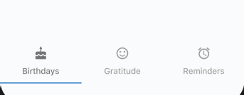
Both the TabBar (Figure 8.3) and TabBarView widgets take a controller property of TabController. The Tab­
Controller is responsible for syncing tab selections between a TabBar and a TabBarView. Since the TabController syncs the tab selections, you need to declare the Single­ TickerProviderStateMixin to the class. In Chapter 7,

“Adding Animation to an App,” you learned how to imple- ment the Ticker class that is driven by the Schedule­ Binding.scheduleFrameCallback reporting once per animation frame. It is trying to sync the animation to be
as smooth as possible.
FIGURE 8.3: TabBar in the Scaffold bottomNavigationBar property

TRY IT OUT Creating the TabBar and TabBarView App
In this example, the TabBar widget is the child of a bottomNavigationBar property. This places the TabBar at the bottom of the screen, but you could also place it in the AppBar or a custom location. When you use a TabBar in combination with the TabBarView, once a Tab is selected, it automatically displays the appropriate content. In this project, the content is represented by three separate pages. You’ll create the same three pages as you did in the BottomNavigationBar project.
- Create a new Flutter project and name it ch8_tabbar. Once more, you can follow the instructions in Chapter 4. For this project, you need to create only the pages folder.
- Open the home.dart file, and add to the body a SafeArea with TabBarView as a child. The TabBarView controller property is a TabController variable called _tabController. Add to the TabBarView children property the Birthdays(), Gratitude(), and Reminders() pages that you’ll create in step 3.
body: SafeArea( child: TabBarView(

controller: _tabController, children: [
Birthdays(), Gratitude(), Reminders(),
],
),
),

- This time you’ll create the pages that you are navigating to first. Like in the BottomNavigationBar app, create three StatelessWidget pages and call them Birthdays, Gratitude, and Reminders. Each page has a Scaffold with Center() for the body. The Center child is an Icon with the size of 120.0 pixels and a color.
The following are the three Dart files, birthdays.dart, gratitude.dart, and reminders.dart:

// birthdays.dart
import 'package:flutter/material.dart';

class Birthdays extends StatelessWidget { @override
Widget build(BuildContext context) { return Scaffold(
body: Center( child: Icon(
Icons.cake, size: 120.0,
color: Colors.orange,
),
),
);
}
}

// gratitude.dart
import 'package:flutter/material.dart';

class Gratitude extends StatelessWidget { @override
Widget build(BuildContext context) { return Scaffold(
body: Center( child: Icon(
Icons.sentiment_satisfied, size: 120.0,
color: Colors.lightGreen,
),
),
);
}
}

// reminders.dart
import 'package:flutter/material.dart';

class Reminders extends StatelessWidget { @override
Widget build(BuildContext context) { return Scaffold(
body: Center( child: Icon(
Icons.access_alarm, size: 120.0,
color: Colors.purple,
),
),
);
}
}
- Import each page in the home.dart file.
import 'package:flutter/material.dart'; import 'birthdays.dart';
import 'gratitude.dart'; import 'reminders.dart';

- Declare the TickerProviderStateMixin to the _HomeState class by adding with TickerProviderStateMixin. The AnimationController vsync argument will use it.
class _HomeState extends State<Home> with SingleTickerProviderStateMixin {...}
- Declare a TabController variable by the name of _tabController. Override the initState() method to initialize the _tabController with the vsync argument and a length value of 3. The vsync is referenced by this, meaning this reference of the _HomeState class. The length repre- sents the number of Tabs to show. Add a Listener to the _tabController to catch when a Tab is changed. Then override the dispose() method for when the page closes to properly dispose of the
_tabController.
Note in the _tabChanged method you check for indexIsChanging before showing which Tab is tapped. If you do not check for indexIsChanging, then the code runs twice.

class _HomeState extends State<Home> with SingleTickerProviderStateMixin { TabController _tabController;

@override
void initState() { super.initState();

_tabController = TabController(vsync: this, length: 3);
_tabController.addListener(_tabChanged);
}

@override
void dispose() { super.dispose();

@override
void dispose() {
_tabController.dispose();

super.dispose();
}
_tabController.dispose();
}

void _tabChanged() {
// Check if Tab Controller index is changing, otherwise we get the notice twice if (_tabController.indexIsChanging) {
print('tabChanged: ${_tabController.index}');
}
}

- Add a TabBar as a child of the bottomNavigationBar Scaffold property.
bottomNavigationBar: SafeArea( child: TabBar(),
),

- Pass the _tabController for the TabBar controller property. I customized the labelColor and unselectedLabelColor by using, respectively, Colors.black54 and Colors.black38, but feel free to experiment using different colors.
bottomNavigationBar: SafeArea( child: TabBar(
controller: _tabController, labelColor: Colors.black54, unselectedLabelColor: Colors.black38,
),
),
- Add three Tab widgets to the tabs widget list. Customize each Tab icon and text. bottomNavigationBar: SafeArea(
child: TabBar(
controller: _tabController, labelColor: Colors.black54, unselectedLabelColor: Colors.black38, tabs: [
Tab(
icon: Icon(Icons.cake), text: 'Birthdays',
),
Tab(
icon: Icon(Icons.sentiment_satisfied), text: 'Gratitude',
),
Tab(
icon: Icon(Icons.access_alarm), text: 'Reminders',
),
],
),
),

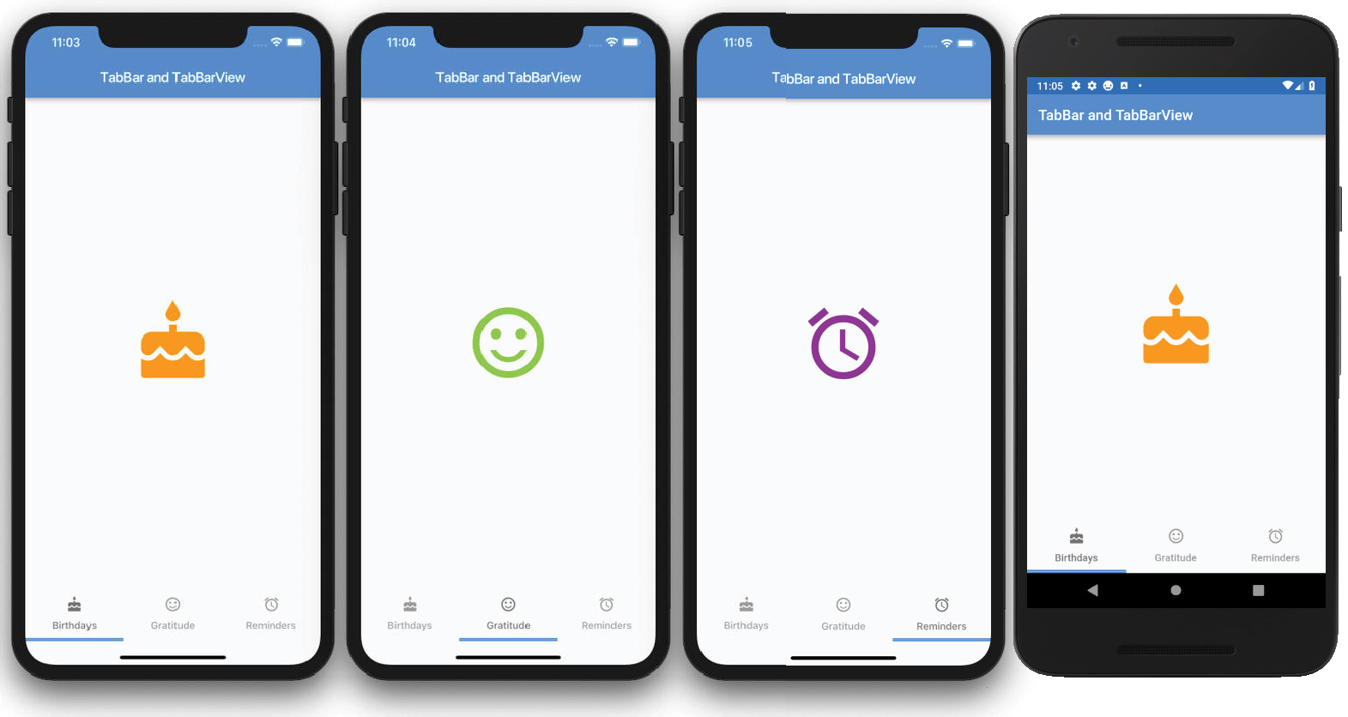

How It Works
When TabBar and TabBarView are used together, the correct associated page is automatically loaded. When the user swipes the TabBarView left or right, it scrolls to the correct page and selects the corre- sponding tab in the TabBar. All of these powerful features are built in; no custom coding is necessary.
How does it know which page belongs to which tab? The TabController is responsible for syncing tab selections between a TabBar and a TabBarView. Since the TabController syncs the tab selections, you need to declare the SingleTickerProviderStateMixin to the class.
Both the TabBar and TabBarView use the same TabController. The TabController is initiated by passing a vsync argument and a length argument. The length argument is the number of tabs to show. An optional TabController Listener is added to listen to Tab changes and take appropriate action if necessary, perhaps saving data before a Tab is switched. Each Tab is added to the TabBar tabs widget list by customizing each icon and text.
TabBarView is responsible for loading the appropriate page when Tab selection changes. The page views are listed as the children property of the TabBarView widget.

USING THE DRAWER AND LISTVIEW
You might be wondering why I’m covering the ListView in this navigation chapter. Well, it works great with the Drawer widget. ListView widgets are used quite often for selecting an item from a list to navigate to a detailed page.

Drawer is a Material Design panel that slides horizontally from the left or right edge of the Scaffold, the device screen. Drawer is used with the Scaffold drawer (left-side) property or endDrawer (right- side) property. Drawer can be customized for each individual need but usually has a header to show an image or fixed information and a ListView to show a list of navigable pages. Usually, a Drawer is used when the navigation list has many items.
To set the Drawer header, you have two built-in options, the UserAccountsDrawerHeader or the DrawerHeader. The UserAccountsDrawerHeader is intended to display the app’s user details by setting the currentAccountPicture, accountName, accountEmail, otherAccountsPictures, and decoration properties.

// User details UserAccountsDrawerHeader(
currentAccountPicture: Icon(Icons.face,), accountName: Text('Sandy Smith'),
accountEmail: Text('sandy.smith@domainname.com'), otherAccountsPictures: <Widget>[
Icon(Icons.bookmark_border),
],
decoration: BoxDecoration( image: DecorationImage(
image: AssetImage('assets/images/home_top_mountain.jpg'), fit: BoxFit.cover,
),
),
),
DrawerHeader is intended to display generic or custom information by setting the padding, child, decoration, and other properties.

// Generic or custom information DrawerHeader(
padding: EdgeInsets.zero, child: Icon(Icons.face),
decoration: BoxDecoration(color: Colors.blue),
),
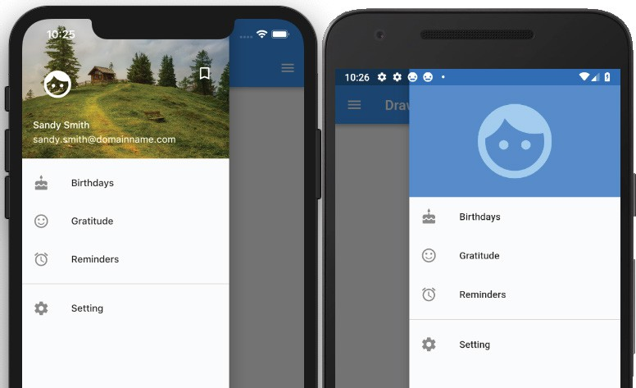
The standard ListView constructor allows you to build a short list of items quickly. The next chapter will go into more depth on how to use the ListView. see Figure

TRY IT OUT Creating the Drawer App
In this example, the Drawer is added to the drawer or endDrawer property of the Scaffold. The drawer and endDrawer properties slide the Drawer from either left to right (TextDirection.ltr) or right to left (TextDirection.rtl). In this example, you’ll add both the drawer and the endDrawer to show how
to use both. You use the UserAccountsDrawerHeader to the drawer (left-side) property and the
DrawerHeader to the endDrawer (right-side) property.
You use the ListView to add the Drawer content and ListTile to align text and icons for the menu list easily. In this project, you use the standard ListView constructor since you have a small list of menu items.
- Create a new Flutter project and name it ch8_drawer, following the instructions in Chapter 4. For this project, you need to create the pages, widgets, and assets/images folders. Copy the home_top_mountain.jpg image to the assets/images folder.
- Open the pubspec.yaml file and under assets add the images folder.
# To add assets to your application, add an assets section, like this: assets:
­ assets/images/
- Add the folder assets and subfolder images at the project’s root and then copy the home_top_ mountain.jpg file to the images folder.
- Click the Save button; depending on the editor you are using, it automatically runs the flutter packages get. Once finished, it shows a message of Process finished with exit code 0.
If it does not automatically run the command for you, open the Terminal window (located at the bottom of your editor) and type flutter packages get.
- Create the pages that you are navigating to first. Create three StatelessWidget pages and call them Birthdays, Gratitude, and Reminders. Each page has a Scaffold with Center() for the body. The Center child is an Icon with the size value of 120.0 pixels and a color property.
class Birthdays extends StatelessWidget { @override
Widget build(BuildContext context) { return Scaffold(
body: Center( child: Icon(
Icons.cake, size: 120.0,
color: Colors.orange,
),
),
);
}
}
- Add the AppBar to the Scaffold, which is needed for navigating back to the home page. The following shows the three Dart files, birthdays.dart, gratitude.dart, and reminders.dart:
// birthdays.dart
import 'package:flutter/material.dart';

class Birthdays extends StatelessWidget { @override
Widget build(BuildContext context) { return Scaffold(
appBar: AppBar(
title: Text('Birthdays'),
),
body: Center( child: Icon(
Icons.cake, size: 120.0,
color: Colors.orange,
),
),
);
}
}
// gratitude.dart
import 'package:flutter/material.dart';

class Gratitude extends StatelessWidget { @override
Widget build(BuildContext context) { return Scaffold(
appBar: AppBar(
title: Text('Gratitude'),
),
body: Center( child: Icon(
Icons.sentiment_satisfied, size: 120.0,
color: Colors.lightGreen,
),
),
);
}
}

// reminders.dart
import 'package:flutter/material.dart';

class Reminders extends StatelessWidget { @override
Widget build(BuildContext context) { return Scaffold(
appBar: AppBar(
title: Text('Reminders'),
),
body: Center( child: Icon(
Icons.access_alarm, size: 120.0,
color: Colors.purple,
),
),
);
}
}
- The left and right Drawer widgets share the same menu list, and you’ll write it first. Create a new Dart file in the widgets folder. Right-click the widgets folder and then select New ➪ Dart File, enter menu_list_tile.dart, and click the OK button to save.
- Import the material.dart, birthdays.dart, gratitude.dart, and reminders.dart classes (pages). Add a new line and then start typing st; the autocompletion help opens, so select the stful abbreviation and give it a name of MenuListTileWidget.
import 'package:flutter/material.dart';
import 'package:ch8_drawer/pages/birthdays.dart'; import 'package:ch8_drawer/pages/gratitude.dart'; import 'package:ch8_drawer/pages/reminders.dart';
- The Widget build(BuildContext context) returns a Column. The Column children widget list contains multiple ListTiles representing each menu item. Add a Divider widget with the color property set to Colors.grey before the last ListTile widget.
@override
Widget build(BuildContext context) { return Column(
children: <Widget>[ ListTile(), ListTile(), ListTile(),
Divider(color: Colors.grey), ListTile(),
],
);
}

- For each ListTile, set the leading property as an Icon and the title property as a Text. For the onTap property, you first call Navigator.pop() to close the open Drawer and then call Navigator.push() to open the selected page.
@override
Widget build(BuildContext context) { return Column(
children: <Widget>[ ListTile(
leading: Icon(Icons.cake), title: Text('Birthdays'), onTap: () {
Navigator.pop(context); Navigator.push(
context, MaterialPageRoute(
builder: (context) => Birthdays(),
),
);
},
),
ListTile(
leading: Icon(Icons.sentiment_satisfied), title: Text('Gratitude'),
onTap: () { Navigator.pop(context); Navigator.push(
context, MaterialPageRoute(
builder: (context) => Gratitude(),
),

);
},
),
ListTile(
leading: Icon(Icons.alarm), title: Text('Reminders'),

onTap: () { Navigator.pop(context); Navigator.push(
context, MaterialPageRoute(
builder: (context) => Reminders(),
),
);
},
),
Divider(color: Colors.grey), ListTile(
leading: Icon(Icons.settings), title: Text('Setting'),
onTap: () { Navigator.pop(context);
},
),
],
);
}
- Create a new Dart file in the widgets folder. Right-click the widgets folder and then select New ➪
Dart File, enter left_drawer.dart, and click the OK button to save.
- Import the material.dart library and the menu_list_tile.dart class.
import 'package:flutter/material.dart';
import 'package:ch8_drawer/widgets/menu_list_tile.dart';

- Add a new line and then start typing st; the autocompletion help opens. Select the stful abbrevia- tion and give it a name of LeftDrawerWidget.
class LeftDrawerWidget extends StatelessWidget { const LeftDrawerWidget({
Key key,
}) : super(key: key);

@override
Widget build(BuildContext context) { return Drawer();
}
}

- The Widget build(BuildContext context) returns a Drawer. The Drawer child is a ListView children list widget of a UserAccountsDrawerHeader widget and a call to the const MenuListTileWidget() widget class. To fill the entire Drawer space, you set the ListView padding property to EdgeInsets.zero.
@override
Widget build(BuildContext context) { return Drawer(

child: ListView(
padding: EdgeInsets.zero,

children: <Widget>[ UserAccountsDrawerHeader(), const MenuListTileWidget(),
],
),
);
}

- For the UserAccountsDrawerHeader, set the currentAccountPicture, accountName, account­ Email, otherAccountsPictures, and decoration properties.
@override
Widget build(BuildContext context) { return Drawer(
child: ListView(
padding: EdgeInsets.zero, children: <Widget>[
UserAccountsDrawerHeader( currentAccountPicture: Icon(
Icons.face, size: 48.0,
color: Colors.white,
),
accountName: Text('Sandy Smith'),
accountEmail: Text('sandy.smith@domainname.com'), otherAccountsPictures: <Widget>[
Icon(
Icons.bookmark_border, color: Colors.white,
)
],
decoration: BoxDecoration( image: DecorationImage(
image: AssetImage('assets/images/home_top_mountain.jpg'), fit: BoxFit.cover,
),
),
),
const MenuListTileWidget(),
],
),
);
}
- Create a new Dart file in the widgets folder. Right-click the widgets folder and then select New ➪ Dart File, enter right_drawer.dart, and click the OK button to save. Import the material.dart library and the menu_list_tile.dart class.
import 'package:flutter/material.dart';
import 'package:ch8_drawer/widgets/menu_list_tile.dart';

- Add a new line and then start typing st; the autocompletion help opens. Select the stful abbrevia- tion and give it a name of RightDrawerWidget.
class RightDrawerWidget extends StatelessWidget { const RightDrawerWidget({
Key key,
}) : super(key: key);

@override
Widget build(BuildContext context) { return Drawer();
}
}

- The Widget build(BuildContext context) returns a Drawer. The Drawer child is a ListView children list of a DrawerHeader widget and a call to the const MenuListTileWidget() widget class. To fill the entire Drawer space, you set the ListView padding property to EdgeInsets.zero.
@override
Widget build(BuildContext context) { return Drawer(
child: ListView(
padding: EdgeInsets.zero, children: <Widget>[
DrawerHeader(),
const MenuListTileWidget(),
],
),
);
}

- For the DrawerHeader, set the padding, child, and decoration properties.
@override
Widget build(BuildContext context) { return Drawer(
child: ListView(
padding: EdgeInsets.zero, children: <Widget>[
DrawerHeader(
padding: EdgeInsets.zero, child: Icon(
Icons.face, size: 128.0,
color: Colors.white54,
),
decoration: BoxDecoration(color: Colors.blue),
),
const MenuListTileWidget(),
],
),
);
}

- Open the home.dart file and import the material.dart, birthdays.dart, gratitude.dart, and
reminders.dart classes.
import 'package:flutter/material.dart'; import 'birthdays.dart';
import 'gratitude.dart'; import 'reminders.dart';
- Add to the body a SafeArea with a Container as a child. body: SafeArea(
child: Container(),
),

- Add to the Scaffold drawer property a call to the LeftDrawerWidget() widget class and for the
endDrawer property a call to the RightDrawerWidget() widget class.
Note that you use the const keyword before calling each widget class to take advantage of caching and subtree rebuilding for better performance.

return Scaffold( appBar: AppBar(
title: Text('Drawer'),
),
drawer: const LeftDrawerWidget(), endDrawer: const RightDrawerWidget(), body: SafeArea(
child: Container(),
),
);
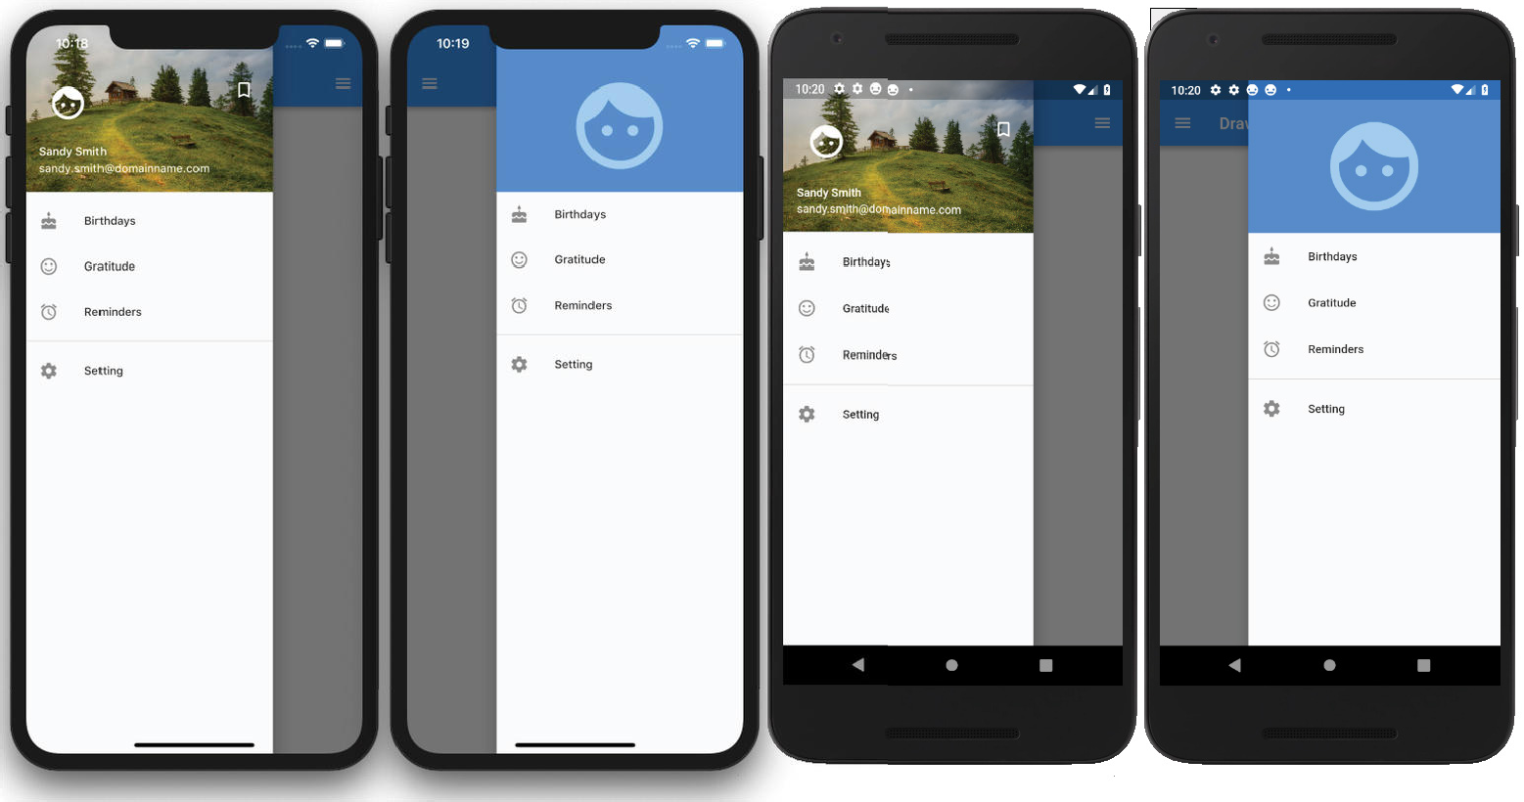

How It Works
To add a Drawer to an app, you set the Scaffold drawer or endDrawer property. The drawer and endDrawer properties slide the Drawer from either left to right (TextDirection.ltr) or right to left (TextDirection.rtl).
The Drawer widget takes a child property, and you passed a ListView. Using a ListView allows you to create a scrollable menu list of items. For the ListView children widget list, you created two widget classes, one to build the Drawer header and one to build the list of menu items. To set the Drawer header, you have two options, UserAccountsDrawerHeader or DrawerHeader. These two widgets easily allow you to set header content depending on the requirements. You looked at two examples for the Drawer header by calling the appropriate widget class LeftDrawerWidget() or RightDrawerWidget().
For the menu items list, you used the MenuListTileWidget() widget class. This class returns a Column widget that uses the ListTile to build your menu list. The ListTile widget allows you to set the leading Icon, title, and onTap properties. The onTap property calls Navigator.pop() to close Drawer and calls Navigator.push() to navigate to the selected page.
This app is an excellent example of creating a shallow widget tree by using widget classes and separat- ing them into individual files for maximum reuse. You also nested widget classes with the left and right widget classes both calling the menu list class.

